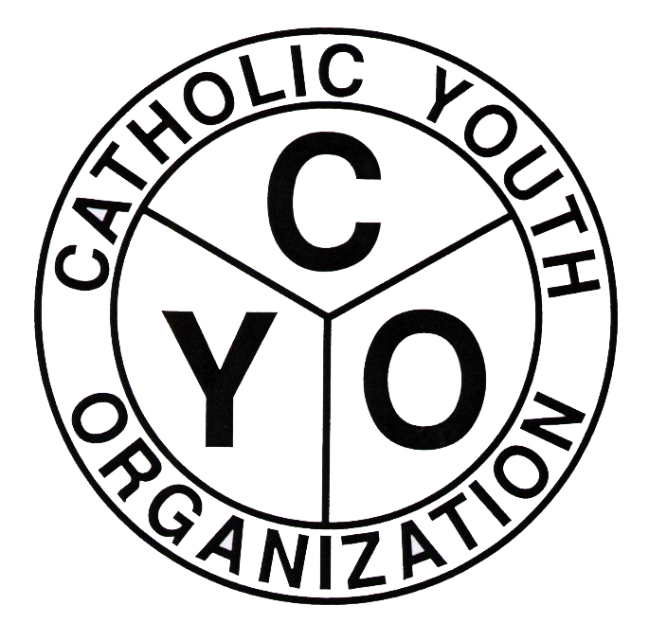
Catholic Youth Organization
Diocese of Brooklyn
7200 Douglaston Parkway,
Douglaston, NY 11362
Tel.: 718.281.9550

2024 CYO BOYS’ HIGH SCHOOL BASKETBALL LEAGUE
ENTRY FORM
PARISH: _______________________________________________________________________
HIGH SCHOOL DIVISIONS # TEAMS
TYRO (’09/’10) ________
JUNIOR (‘07/’08) ________

ENTRY FEE: $250.00 PER TEAM TOTAL # OF TEAMS __________ TOTAL AMOUNT DUE: ______________
PARISH ATHLETIC REPRESENTATIVE ATHLETIC DIRECTOR
NAME ________________________________ _____________________________________
CYO USE ONLY
Home Phone # __________________________ ___________________________
Cell Phone # ____________________________ ___________________________
Email __________________________________ _______________________________________
ENTRY APPROVED BY:
PAR: _______________________________ PASTOR/MODERATOR: _________________________________

BOYS’ HIGH SCHOOL BASKETBALL ENTRY FOR 2024
PARISH: ________________________________________
SCHEDULING CONFLICTS: (PARISH FUNCTIONS MUST BE RELIGIOUS AND/OR EDUCATIONAL)
TEAM DATE TIME(S) REASON

COACHES INFORMATION SHEET AND COURT AVAILABILITY FORM MUST ACCOMPANY THIS ENTRY FORM
Entry Forms are due: September 2, 2024
Completed rosters are due: September 9, 2024
Waiver Requests are due: September 6, 2024
Schedule Distribution: September 6, 2024
*Schedules will also be available on the CYO website (www.cyodob.org)
Game will begin the weekend of September 13-15, 2024.
NOTE: Playoff qualification requirements for the Tyro and Junior divisions will be announced at the start of the season.

